Trainee Class Notes Content – Dealing with Depression

C DEALING WITH DEPRESSION

GOALS AND OBJECTIVES

I. VIDEO

II. SKILL PRACTICE

You have learned a lot about dealing with and helping depressed people. Now you can practice some of the skills you have learned.

Focus Note 1
CARE PARTNER’S SITUATION DESCRIPTION FOR SKILL PRACTICE

You have been working with this care receiver for several months, ever since he or she retired. Your care receiver has been surprised by how difficult retirement is; he or she expected it to be enjoyable, but didn't make any plans for what he or she was going to do. You have been listening to his or her feelings and also gently encouraging your care receiver to realize the need to cope with reality instead of hanging on to his or her fantasies.

Focus Note 2
CARE RECEIVER’S SITUATION DESCRIPTION FOR SKILL PRACTICE

You have been feeling down for several months since you retired. This has taken you by surprise---you expected to enjoy retirement. Just the other day you saw a new car that really captured your fancy. Whenever you think about that car, you feel happier. You have decided to buy a car like that one because you are sure it will make you happy again. You cannot afford
such a car and you don't know how you will pay for it, but you just have to have it. You don't want to feel sad anymore.

Focus Note 3
DISCUSSION QUESTIONS

1. What characteristics of depression did the care receiver show?
2. How did the Care Partner try to care for the care receiver's depression?
3. What did the Care Partner do that worked well? What would the Care Partner do differently next time?
4. What did you learn from this skill practice that you will try to remember or do when you care for a mildly to moderately depressed care receiver?

III. QUESTION AND ANSWER

How to Care for Mildly to Moderately Depressed Persons

A. Be Patient

Caring for depressed people can require a lot of patience. Depressed care receivers may respond slowly and repeat themselves a lot. It could be easy to feel frustrated or even bored with the conversation. By patiently allowing the conversation to go at your care receiver's speed and responding attentively to thoughts you have heard expressed many times before, you will provide just the care your care receiver needs. Remain patiently process-oriented and allow God and the care receiver to solve the problems in their own way and time.

B. Be Accepting

Your care receiver may experience rejection from others who find him or her too difficult to be around. People may avoid talking with your care receiver because they feel so frustrated and bored with the conversation. You can bring light into a dark place by accepting your care receiver, letting him or her know that you accept his or her pain and will not reject him or her.

C. Initiate Conversation

With depressed care receivers, you will need to initiate conversations more often than with
people who aren't depressed. Depressed people can be quite passive. They are much less likely to initiate conversations than many other care receivers. You may have to be the one to initiate most, or even all, of the conversations at first. Prolonged silences can be very uncomfortable for depressed people. They may blame themselves for the silence, or be thinking all kinds of negative thoughts that will only add to the depression. This is why it is better to keep silences shorter and initiate more of the conversation yourself, using lead-in statements or leading questions. Don't rush in to fill every void, but interrupt silences sooner than you would with other care receivers.

D. Encourage Expression of Feelings

While exploring feelings is important with any care receiver, it is particularly so with depressed people. They have an especially difficult time expressing their feelings. Care for them by giving them every opportunity to talk about what they are feeling.

E. Take Your Care Receiver Seriously

When you are dealing with a depressed person, you need to take his or her pain seriously. Resist any temptation to try to cheer up your care receiver or to use humor to help him or her snap out of the depression. It won't work, and it will not show empathy with your care receiver's feelings.

F. Discourage Self-Defeating Behavior

A depressed person may want abruptly to quit school or a job, or end an important relationship. He or she may later deeply regret such impulsive, self-defeating choices.
Do what you can to discourage such potentially harmful decisions while emphasizing your care, concern, and presence. You may offer an opinion, make a suggestion, or even contract with the care receiver to delay temporarily a potentially self-defeating major decision.

G. Instill Hope

Since hopelessness is a main characteristic of depression, an important part of caring for depressed people is to instill hope. One way to help give hope is to help the depressed person identify the problem that caused the depression.

H. Give Christian Assurances

At the right time, make use of some of the traditional resources of Christianity. The Scriptures contain many passages that might instill hope.

I. Help Depressed Persons to Do Something

Some depressed people are unable to take that first step that would help them get out of their depression. Encourage care receivers to take intentional small steps to accomplish tasks. Make the first task very easy, one they can surely succeed in taking. Then subsequent steps will become easier, and care receivers may be on the way to rising above the depression.

J. Promote Independence Gradually

Some depressed persons become helplessly dependent on others. Generally speaking, as soon as care receivers begin to come out of their depression, begin gradually to encourage independent behavior. Affirm every example you see of care receivers' taking responsibility for themselves. When care receivers are depending on you too much, ask what they could do for themselves. Certainly don't cut care receivers off abruptly, but work with them gradually to become more independent.

K. Express Support Physically

Physical expressions of support can be extremely helpful in your caring relationship. These might consist of a hug, a handshake, putting your arm around the care receiver, or even placing a hand on the person's shoulder or forearm. Sometimes these nonverbal expressions of support and presence mean more than any words you could say. Take care that the physical expression of support is appropriate. Don't do anything that makes either you or the care receiver uncomfortable. If you are uncertain, ask.

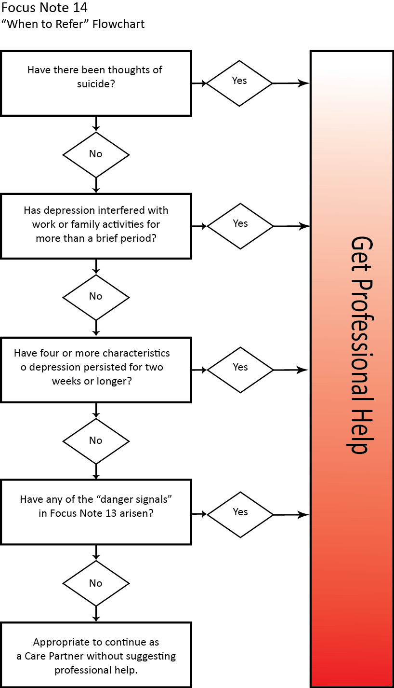
(Focus Note 13)
DEPRESSION DANGER SIGNALS

Feelings of unhappiness intensify, and the person continues to be depressed or hopeless after meeting with the [caregiver] a few times. Negative ideas about the self and the future gain more and more prominence. The unhappy feeling becomes more intense. A person says, "All this talking makes no difference. Maybe there is no hope."

The person is severely withdrawn, so withdrawn that he finds it difficult to communicate his feelings or events in his life. He is slowed down perceptibly, physically and mentally.

The person is entertaining suicidal ideas. He may have attempted suicide before and is talking as if this may be a way out of his dilemma. For example, he may say, "Everyone would be better off if I weren't around anymore," or "I'd be better off dead."

He manifests hidden suicidal intent. After being very low, the person suddenly is in a happier mood and seems calm and accepting of his situation. He is putting his affairs in order and is giving away prized possessions, as if a decision has been made…

The person distorts reality and expresses bizarre or irrational thoughts about events and people. She may say, "My women's fellowship is always talking about me and making fun of me. I won't go anymore."

The depression permeates his total life. The mood is interfering pervasively with many aspects of his existence---work, love, thinking, decision making, physical well-being, faith, and so on.

Depression has become a way of life. The person seems to have accepted and embraced chronic depression as a style of life, is constantly justifying it, and apparently wishes to maintain it.

The person is unable to identify losses or the focal problem. Even after considerable discussion and exploration, the person is unable to pin­point anything that has triggered the depression or anxiety he is feeling. He cannot say when he began feeling this way or what unpleasant event may be related to his despondent mood. He may say, "I don't know…I guess I've been down about things all my adult life."

Masked signs of depression are showing up. He has a host of physical complaints for which no physical cause can be found by a doctor. He masks depression with a forced, "Christian" cheerfulness, or seems to be in perfect control, calm and rational.

He seems to be insulated from his feelings. The person is unable to express, or has obliterated, any feelings about a significant loss in his life. He may be "numb" more than a year after his loss and cannot feel sadness, anger, guilt, doubt, confusion, or other signs of normal grief.

The [caregiver] feels manipulated. Though this might be the [caregiver's] own problem in part, he may also have "objective" evidence…that the person may be using the low mood and suicidal threats to indirectly control the people in his environment. [The care receiver] is able to change his mood when his wishes are acceded to.

Common Feelings Related to Depression

Experiencing different emotions is as normal as taking a breath; however, when those emotions impede a person’s ability to function effectively in important areas of their life, it may be a sign they are depressed and need support. Below are some common feelings people report experiencing when they are depressed. Review the list to better understand the feelings a care receiver might express if they are experiencing depression or symptoms of depression.
- Feeling sad, empty, or hopeless
- Decreased enjoyment from activities that were previously enjoyable
- Difficulty sleeping or excessive sleeping
- Feeling worthless or excessively guilty
- Difficulty concentrating or making decisions (indecisive)
- Change in appetite- poor appetite or overeating
- Decreased energy or feeling fatigued
- Low self-esteem
- Thoughts about death
These feelings and related changes in a person’s behavior typically differ from the way they would normally feel and behave. Often, the more depressive symptoms a person experiences, the greater the impact on their ability to function. For example, if a care receiver has increased fatigue, decreased enjoyment in activities, and excessive guilt, they might talk about arriving to work or other scheduled activities late or not attending at all and then berating themselves for not being able to “get it together”. Everyone has a bad day occasionally; however, when a person is dealing with depression, those feelings can last anywhere from days to years and can be quite impactful to their ability to function effectively. As a Care Partner, you have the opportunity to ask the Holy Spirit to help you walk alongside the person and be a physical representation of God’s love and care for them in a time they may feel the most alone.

